Team 4

**Chocoholics Anonymous (ChocAn)**

***Use Case Specification Document***

**Use Case ID: 2**

**Use Case Name: Provider Service Recording Version No. 1**

**Project Document Revision History**

|  |  |  |  |
| --- | --- | --- | --- |
| **Version Number** | **Date** | **Revision Author** | **Description of Revision** |
| 1 | 7/30/23 | Student 1 | Original Revision |
|  |  |  |  |

**Table of Contents**

1. Introduction 4

2. Use Case Information 4

2.1 Actors 4

2.2 Use Case Interaction 4

3. Trigger 4

3.1 The provider service recording use case is initiated by the provider user after the services are performed. 4

3.2 The provider user updates the service record information 4

4. Pre-condition(s) 4

4.1 Provider Directory 4

4.2 Member ID 4

4.3 Provider ID 4

5. Post-condition(s) 5

5.1 Completed Service Record 5

5.2 Incomplete Service Record 5

5.3 Invalid Service ID 5

5.4 Invalid Member ID 5

5.5 Invalid Provider ID 5

6. Use Case Swimlane (Activity) Diagram 6

7. Main/Basic Flow(s) of Events (Happy Path) 8

7.1 Completed Service Record (6.1) 8

7.2 Incomplete Service Record (6.2) 8

7.3 Update Service Record (6.3) 9

7.4 Delete Service Record (6.4) 9

8. Alternate/Exception Flow of Events 9

8.1 Invalid service ID 9

8.2 Invalid member ID 9

8.3 Invalid provider ID 9

8.4 Invalid Service Record ID 9

9. Assumptions/Business Rules including Non-Functional Requirements 9

9.1 No services are provided to an inactive member. 9

10. Use Case Specification Review and Signoff 10

# Introduction

The provider service recording use case entails the provider user logging the service provided and which member received the service. This record includes the date the service is provided and the notes about the service. This use case includes the provider user looking up the service code within the provider directory the specified service provided and the fee associated with the service. Once confirmed the service fee is then included in the service record.

# Use Case Information

## Actors

|  |  |  |
| --- | --- | --- |
| Actor Name | Role | Description |
| User (Provider) | Main | Service provider user entering information and reviewing data. |
| Data Center | Secondary | Data management system of the service directory and record logs |

## Use Case Interaction

The provider service recording use case must happen after the member validation use case. The provider service recording use case must happen before automated reporting.

# Trigger

## The provider service recording use case is initiated by the provider user after the services are performed.

## The provider user updates the service record information

# Pre-condition(s)

## Provider Directory

* + 1. **The provider directory must be populated with all services ids, service name and fees which may be offered by a provider.**

## Member ID

* + 1. **The member ID must be present within the system prior to entering the service record.**

## Provider ID

* + 1. **The provider ID must be present within the system prior to entering the service record.**

# Post-condition(s)

What are ALL the possible output states upon completion of the use case flows?

## Completed Service Record

* + 1. **A completed service record which contains the service record ID, ID of the member, the ID of the provider, service code, the date the service is provided, the notes about**

the service if applicable, the fee associated with the service, and the date and time the record was updated.

## Incomplete Service Record

* + 1. **A service record with a unique service record ID, and any amount of information of the completed service record. It will include the date and time the record was updated.**

## Invalid Service ID

* + 1. **An invalid service ID is found when reviewing to create the service record. No service record is generated.**

## Invalid Member ID

* + 1. **An invalid member ID is found and no service record is generated.**

## Invalid Provider ID

* + 1. **An invalid provider ID is found and no service record is generated.**

# Use Case Swimlane (Activity) Diagram

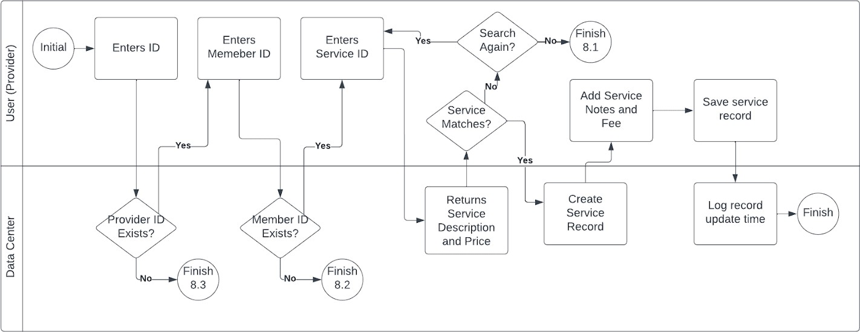

6.1

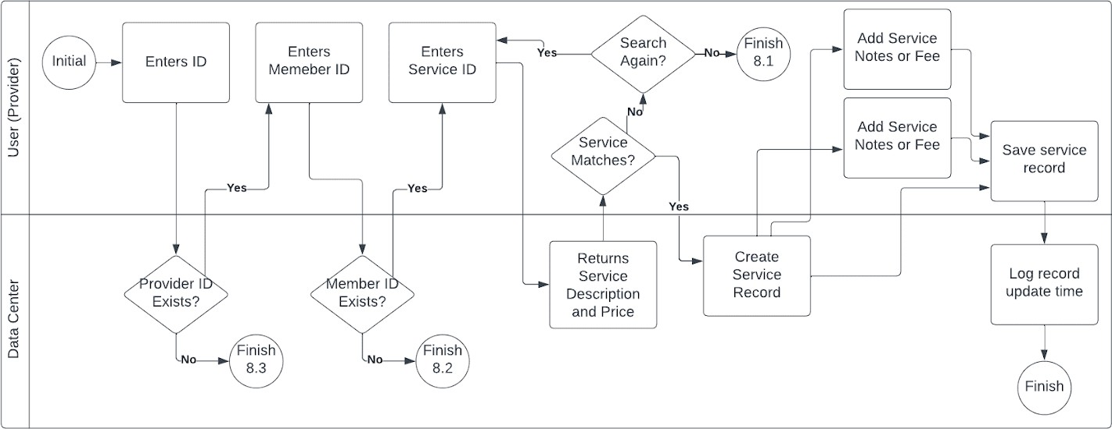

6.2

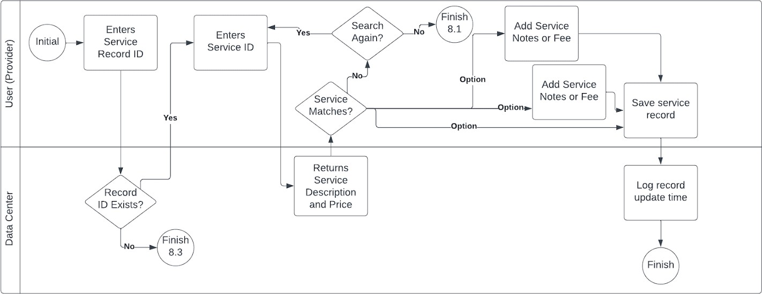

6.3

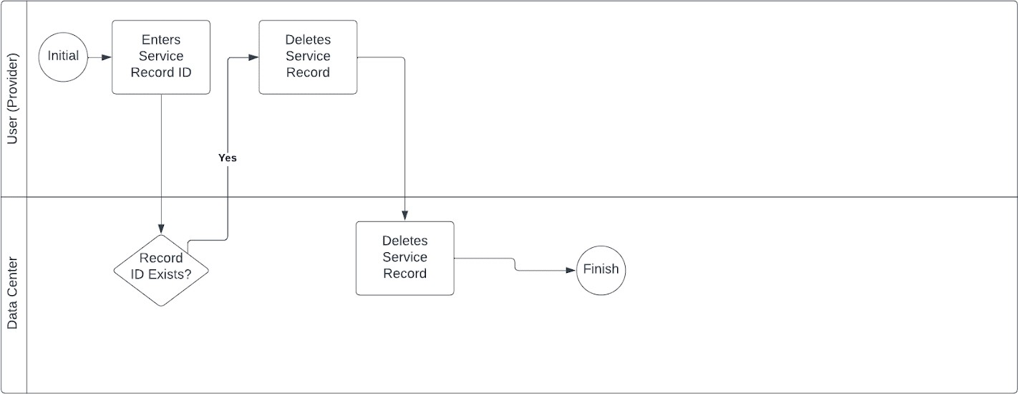

6.4

# Main/Basic Flow(s) of Events (Happy Path)

## Completed Service Record (6.1)

* + 1. **The provider user enters into their terminal with their id number.**
    2. **The data center determines if the ID is present in the database. If the provider ID does not match, follow alternate path 8.3.**
    3. **The provider user scans or types the member’s id number**
    4. **The data center determines if the member ID is present in the database. If the member ID does not match, follow alternate path 8.2.**
    5. **The provider user enters the service ID for the service provided.**
    6. **The data center returns the service details from the service directory for the single service ID.**
    7. **The provider user notes the service name from the directory matches the services provided and the service fee. If the service ID does not match, follow alternate path 8.1.**
    8. **The data center generates the service record ID.**
    9. **The provider user inputs the notes about the service.**
    10. **The provider user inputs the date that the service was provided.**
    11. **The provider user saves the service record.**
    12. **The data center updates the record modification time and the record is stored in the database.**

## Incomplete Service Record (6.2)

* + 1. **The provider user enters into their terminal with their id number.**
    2. **The data center determines if the ID is present in the database. If the provider ID does not match, follow alternate path 8.3.**
    3. **The provider user scans or types the member’s id number**
    4. **The data center determines if the member ID is present in the database. If the member ID does not match, follow alternate path 8.2.**
    5. **The provider user enters the service ID for the service provided.**
    6. **The data center returns the service details from the service directory for the single service ID.**
    7. **The provider user notes the service name from the directory matches the services provided and the service fee. If the service ID does not match, follow alternate path 8.1.**
    8. **The data center generates the service record ID.**
    9. **The provider user enters information for the service notes or fees as desired and saves the updates.**
    10. **The data center updates the record modification time and the record is stored in the database.**

## Update Service Record (6.3)

* + 1. **The provider user enters the service record ID to be modified.**
    2. **The data center returns the current service record information.**
    3. **The provider user may enter any information including notes or fees and correct the date which the service was provided.**
    4. **The data center updates the record modification time and the record is stored in the database.**

## Delete Service Record (6.4)

* + 1. **The provider user opens the service record based on the service record ID.**
    2. **The data center determines if the service record exists.**
    3. **The provider user deletes the service record.**
    4. **The data center removes the record from the database.**

# Alternate/Exception Flow of Events

## Invalid service ID

* + 1. **The provider user service ID was not found or did not match the services provided.**
    2. **The provider user can search again for the service ID or exit.**

## Invalid member ID

* + 1. **The member ID was not found.**
    2. **The provider user can rescan, retype the member ID, or exit.**

## Invalid provider ID

* + 1. **The provider user ID was not found**
    2. **The provider user can return to enter their ID or exit.**

## Invalid Service Record ID

* + 1. **The service record was not found.**

# Assumptions/Business Rules including Non-Functional Requirements

## No services are provided to an inactive member.

# Use Case Specification Review and Signoff

|  |  |  |  |
| --- | --- | --- | --- |
| Review and Signoff of the Use Case Specification | | | |
| Name | Project Team Role | Signature | Date |
| Student 1 | Requirements and Verification | Signature | 8/2/23 |
| Student 2 | Project Manager | Signature | 8/2/23 |
| Student 3 | Hardware and Software Integration | Signature | 8/2/23 |
| Student 4 | Product Validation | Signature | 8/2/23 |
| Client | Client | Signature | 8/2/23 |